Mohammed Uddin

CSC 2110

12/14/2022

***Final Project: CAR DEALERSHIP***

For my dealership main menu, I choose to stick with menu that shows on the doc, First the name of the dealership after that menu starts with first option being Search inventory by the make of car, model of the car, price range of the car and by category. I used polymorphism on my search function. Second option is sell and lease car which lets you sell the old car and new car and only lease the new cars. My third option is to return a lease car if you have any on the lease car file it should goes to the old car inventory and fourth option is to add new and old car to the inventory which goes to files new car goes to Newvehicles.txt and old car goes to the oldvehicles.txt and lastly fifth option which lets you exit the program. I have added test of the program along with the screenshots.

Old Car Inventory:

New Car Inventory:

***My Test plan Step by Step with Screenshot of the program:***

When you run the program, The Main Menu comes up showing the options of the dealership:

The first option is to search the cars from inventory by make, model, year and category.

And If I try pressing any other button that not on the menu it just goes to the main menu again

Press 1 to search the inventory by make, model, price and category

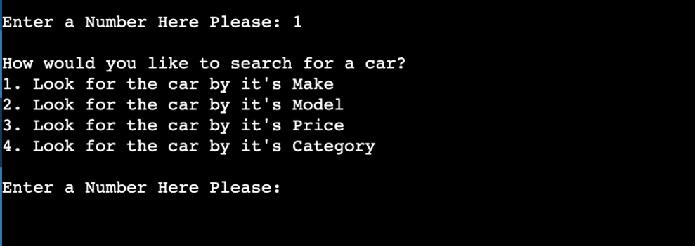

Again press 1 to see the cars by the make of the cars from the inventory:

And if we try with something that is not in the inventory it gives you a message saying this:

Press 2 to see the cars by the model of the cars from the inventory:

Press 3 to see the cars by the price range of the cars from the inventory:

Press 4 to see the cars by the category of the cars from the inventory:

Now we going to second option from the menu to sell and lease the cars from the inventory:

Selling Cars from the old inventory and new inventory from the second selection:

Press 1 to sell a car and again press 1 to sell from new cars inventory:

Before selling the car from the new car inventory:

And after selling the car from the new car inventory:

Again Press 1 to sell a car and press 2 to sell from old cars inventory:

Before selling the car from the old car inventory:

After selling the car from the old car inventory:

Leasing Cars from the old inventory and new inventory from the second selection:

In my dealership I can only lease from the new cars inventory:

After leasing the car, Car gets removed from the inventory and stored to a new file called lesedvehicles.txt.

In this case I have leased The Lexus nx250

Car got remove from the inventory

And stored to the new file



The Third selection from the menu is return a leased car:

After returning a leased car from the leasedvehicles.txt file it gets removed from the file saves in the old cars inventory.

leasedvehicles.txt

Old cars inventory

The fourth selection from the main menu is adding a new and old car to the inventory:

Adding a new car to the inventory:

After the new car has been added the new cars inventory:

Adding an old to the inventory:

After the old car has been added the old cars inventory:

The Fifth selection from the main menu is Exit:

And if I try to exit with different number, it just goes to main menu:

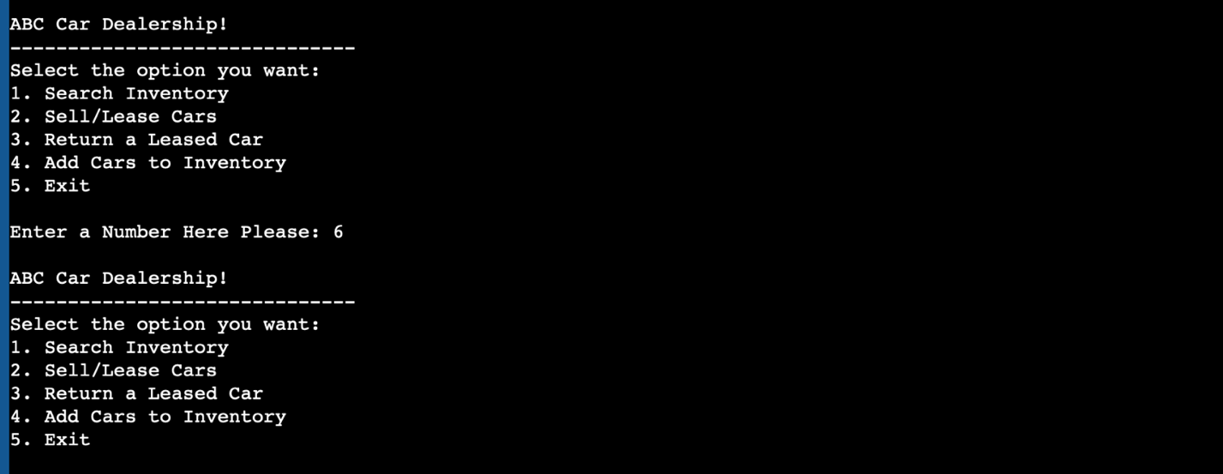

For the Extra Credit I have added the price range option, so it shows the cars in the range:

Also, I made oldvehicles.txt and Newvehicles.txt files where my old cars and new cars being leased and sold from also when I return the leased cars goes to the old cars inventory.

***Thank you, Professor you have a wonderful holiday and Happy New Year!!***